Premature Baby Bootie Pattern
Large and Newborn sizes
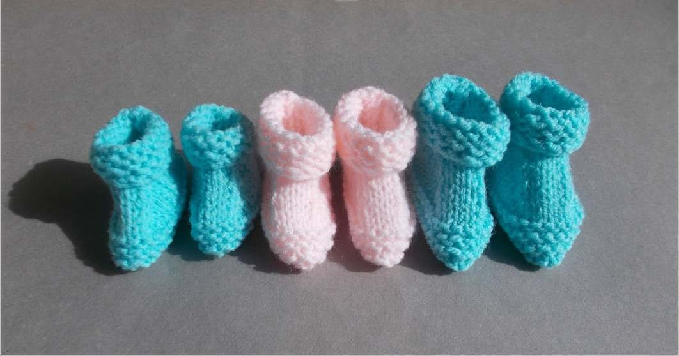
This pattern was developed by Marianna from Marianna’s Lazy Daisy Days and has kindly provided LLTF with permission to use it for our community. For information about Marianna’s patterns please visit:
https://mariannaslazydaisydays.blogspot.com/2015/07/little-babbity-prematurebaby-set.html
Note: Knitting the last row of the booties and casting off with larger knitting needles will make the top of the booties less restricting.

Babbity Baby Booties - Large Premature Baby

Length of sole: 3 ¼” (8.5cm)

Instructions: Make two booties the same

Cast on 33sts

Knit 9 rows

10th Row: Purl
11th Row: K13, k2tog, k3, s1, k1, psso, k13

12th Row: P12, p2tog tbl, p3, p2tog, p12

13th Row: K11, k2tog, k3, s1, k1, psso, k11

14th Row: P10, p2tog tbl, p3, p2tog, p10

15th Row: K9, k2tog, k3, s1, k1, psso, k9

16th Row: P8, p2tog tbl, p3, p2tog, p8

17th Row: K7, k2tog, k3, s1, k1, psso, k7 (19sts)

18th Row: Purl

19th Row: Knit
20th Row: Purl
Knit 7 rows
Cast off LOOSELY

Sew seam along the sole
Sew back seam
Darn away ends

Fold down cuff

* * * * *

Babbity Baby Booties - Newborn Baby

Length of sole: 3 ½ ” (9cm)

Instructions: Make two booties the same

Cast on 36sts

Knit 9 rows

10th Row: Purl
11th Row: K14, k2tog, k4, s1, k1, psso, k14

12th Row: P13, p2tog tbl, p4, p2tog, p13

13th Row: K12, k2tog, k4, s1, k1, psso, k12

14th Row: P11, p2tog tbl, p4, p2tog, p11

15th Row: K10, k2tog, k4, s1, k1, psso, k10

16th Row: P9, p2tog tbl, p4, p2tog, p9

17th Row: K8, k2tog, k4, s1, k1, psso, k8 (22sts)

18th Row: Purl

19th Row: Knit
20th Row: Purl
Repeat the last 2rows once more
Knit 7 rows
Cast off LOOSELY

Sew seam along the sole
Sew back seam
Darn away ends

Fold down cuff

